

AMITY UNIVERSITY
Bengaluru

Lab Manual

Course Title: Linear Algebra

Course Code: MAT1015

Submitted by

Name: Haarish.S

SEN No: A873188425003

Programme: BSc.CSMS

Semester & Year: Fall Semester/ 2025

Ex. No. 1: Gauss Elimination Method

Problem:
Solve the system of linear equation by using Gauss Elimination Method.
x + y + z = 6
2x + 3y + 4z = 20
3x + 2y + z = 13

Aim:

Procedure:

MATLAB Code: Gauss Elimination Method
clc; clear;

% Gauss Elimination Method in MATLAB

A = input('Enter coefficient matrix A: ');
b = input('Enter constant vector b: ');

n = length(b);
Aug = [A b]; % Augmented matrix

% Forward Elimination
for k = 1:n-1
for i = k+1:n
factor = Aug(i,k)/Aug(k,k);
Aug(i,k:end) = Aug(i,k:end) - factor * Aug(k,k:end);
end
end

% Back Substitution
x = zeros(n,1);
x(n) = Aug(n,end) / Aug(n,n);

for i = n-1:-1:1
x(i) = (Aug(i,end) - Aug(i,i+1:n)*x(i+1:n)) / Aug(i,i);
end

disp('Solution using Gauss Elimination Method:')
disp(x)

Output:
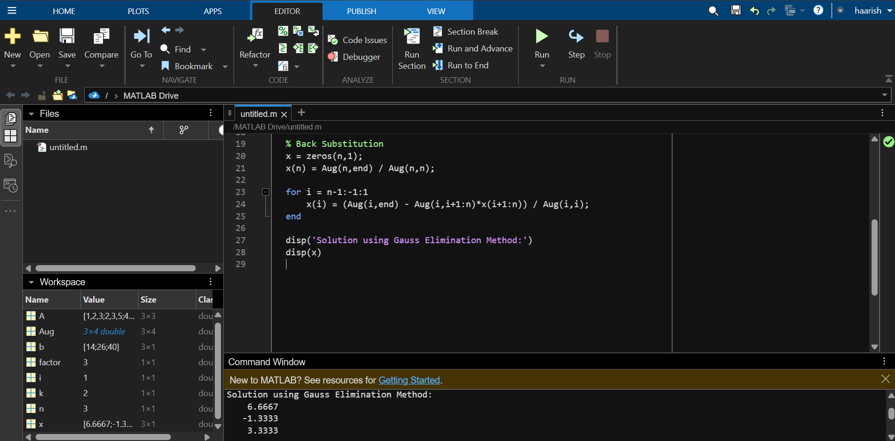

MATLAB Code: Gauss–Jordan Elimination Method
Problem:
Solve the following system by using the Gauss-Jordan elimination method.
x + y + z = 5
2x + 3y + 5z = 8
4x + 5z = 2

Aim:

Procedure:
clc; clear;

% Gauss–Jordan Elimination Method

A = input('Enter coefficient matrix A: ');
b = input('Enter constant vector b: ');

Aug = [A b]; % Augmented matrix
n = size(A,1);

% Gauss–Jordan Elimination
for k = 1:n
% Make the pivot 1
Aug(k,:) = Aug(k,:) / Aug(k,k);

% Make all other entries in column k equal to 0
for i = 1:n
if i ~= k
Aug(i,:) = Aug(i,:) - Aug(i,k) * Aug(k,:);
end
end
end

% Solution vector
x = Aug(:, end);

disp('Solution using Gauss–Jordan Method:')
disp(x)

Output:

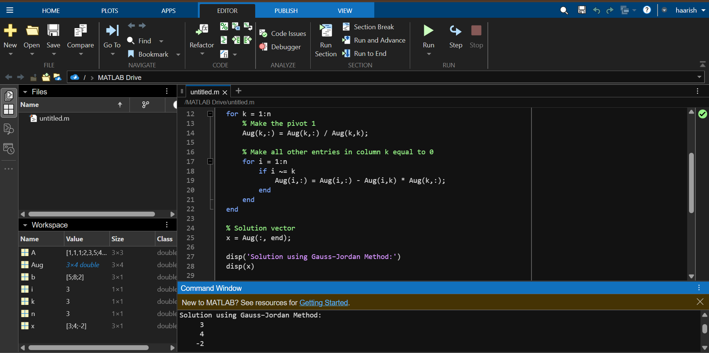

MATLAB Code: Gauss–Jacobi Method
Problem:
Solving systems of linear equations using Gauss Jacobi method.
2x+5y=21
x+2y=8

Aim:

Procedure:
clc; clear;

% Gauss–Jacobi Iteration Method

A = input('Enter matrix A: ');
b = input('Enter vector b: ');
x0 = input('Enter initial guess vector: ');
tol = input('Enter tolerance (e.g., 1e-6): ');
N = input('Enter maximum number of iterations: ');

n = length(b);
x = x0;

for k = 1:N
x_new = zeros(n,1);

for i = 1:n
x_new(i) = (b(i) - A(i,[1:i-1,i+1:n]) * x([1:i-1,i+1:n])) / A(i,i);
end

% Check convergence
if norm(x_new - x, inf) < tol
fprintf('Converged in %d iterations.\n', k);
x = x_new;
break;
end

x = x_new;
end

disp('Solution using Gauss–Jacobi Method:')
disp(x)

Output:

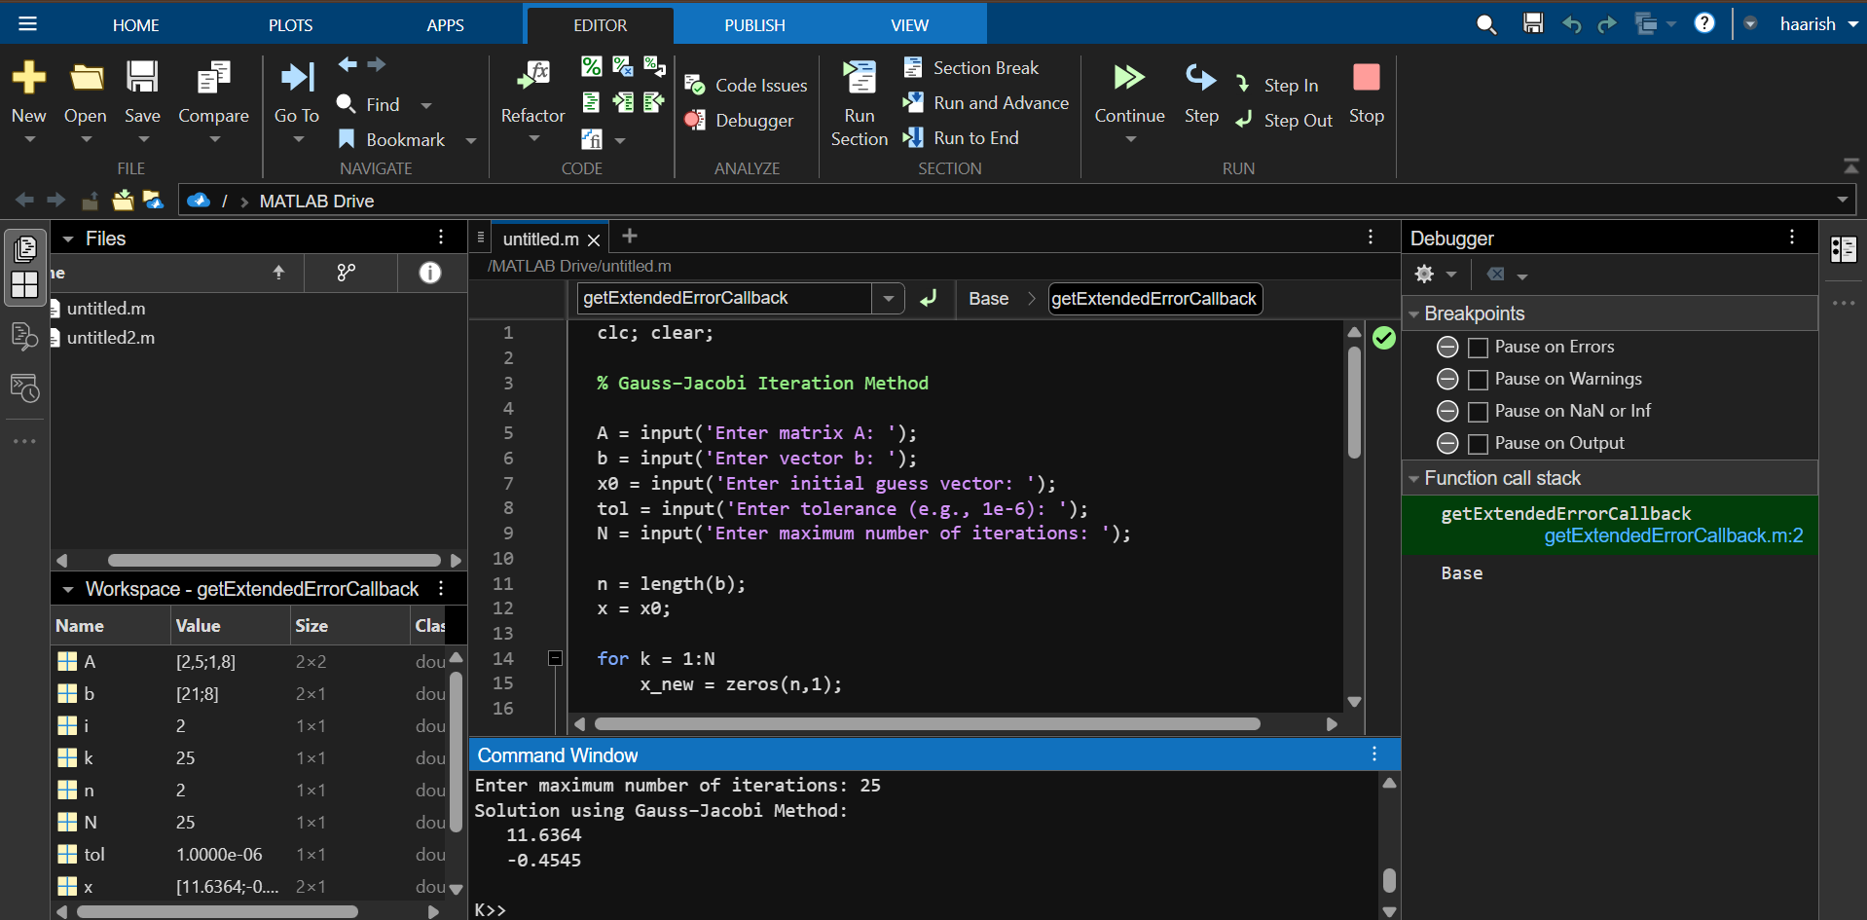

MATLAB Code: Gauss–Seidel Method
Problem:
Solve the systems of linear equations using Gauss Seidel method.
2x+y=8
x+2y=1
Aim:
Procedure:
clc; clear;

% Gauss–Seidel Iteration Method

A = input('Enter matrix A: ');
b = input('Enter vector b: ');
x0 = input('Enter initial guess vector: ');
tol = input('Enter tolerance (e.g., 1e-6): ');
N = input('Enter maximum number of iterations: ');

n = length(b);
x = x0;

for k = 1:N
x_old = x;

for i = 1:n
x(i) = (b(i) - A(i,[1:i-1,i+1:n]) * x([1:i-1,i+1:n])) / A(i,i);
end

% Convergence check
if norm(x - x_old, inf) < tol
fprintf('Converged in %d iterations.\n', k);
break;
end
end

disp('Solution using Gauss–Seidel Method:')
disp(x)

Output:

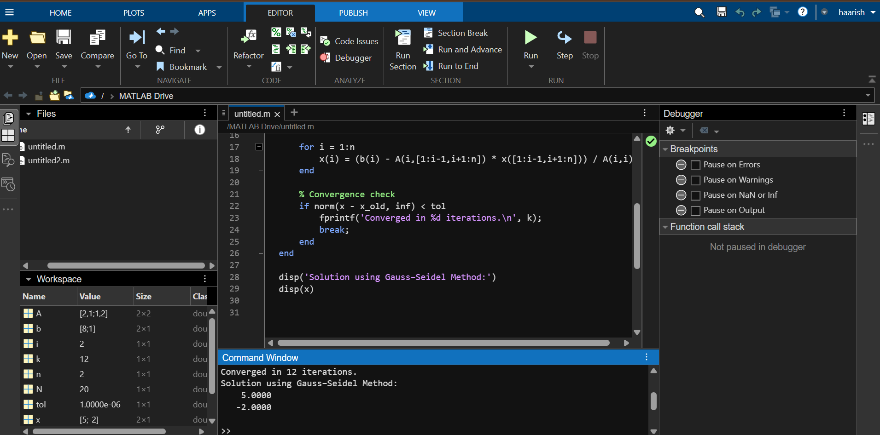

MATLAB Code: LU Decomposition Method
Problem:
Solving systems of linear equations using LU decomposition.
2x+5y=21
x+2y=8
Aim:
Procedure:
clc; clear;

% LU Decomposition Method (Doolittle Method)

A = input('Enter matrix A: ');
b = input('Enter vector b: ');

n = length(b);

L = eye(n); % Lower triangular matrix
U = zeros(n); % Upper triangular matrix

% ------- LU Decomposition -------
for k = 1:n
% Compute U row
U(k, k:n) = A(k, k:n) - L(k,1:k-1) * U(1:k-1, k:n);

% Compute L column
for i = k+1:n
L(i,k) = (A(i,k) - L(i,1:k-1) * U(1:k-1,k)) / U(k,k);
end
end

% ------- Forward substitution (Ly = b) -------
y = zeros(n,1);
for i = 1:n
y(i) = b(i) - L(i,1:i-1) * y(1:i-1);
end

% ------- Back substitution (Ux = y) -------
x = zeros(n,1);
for i = n:-1:1
x(i) = (y(i) - U(i,i+1:n) * x(i+1:n)) / U(i,i);
end

disp('Lower triangular matrix L:');
disp(L);

disp('Upper triangular matrix U:');
disp(U);

disp('Solution vector x:');
disp(x);

Output:

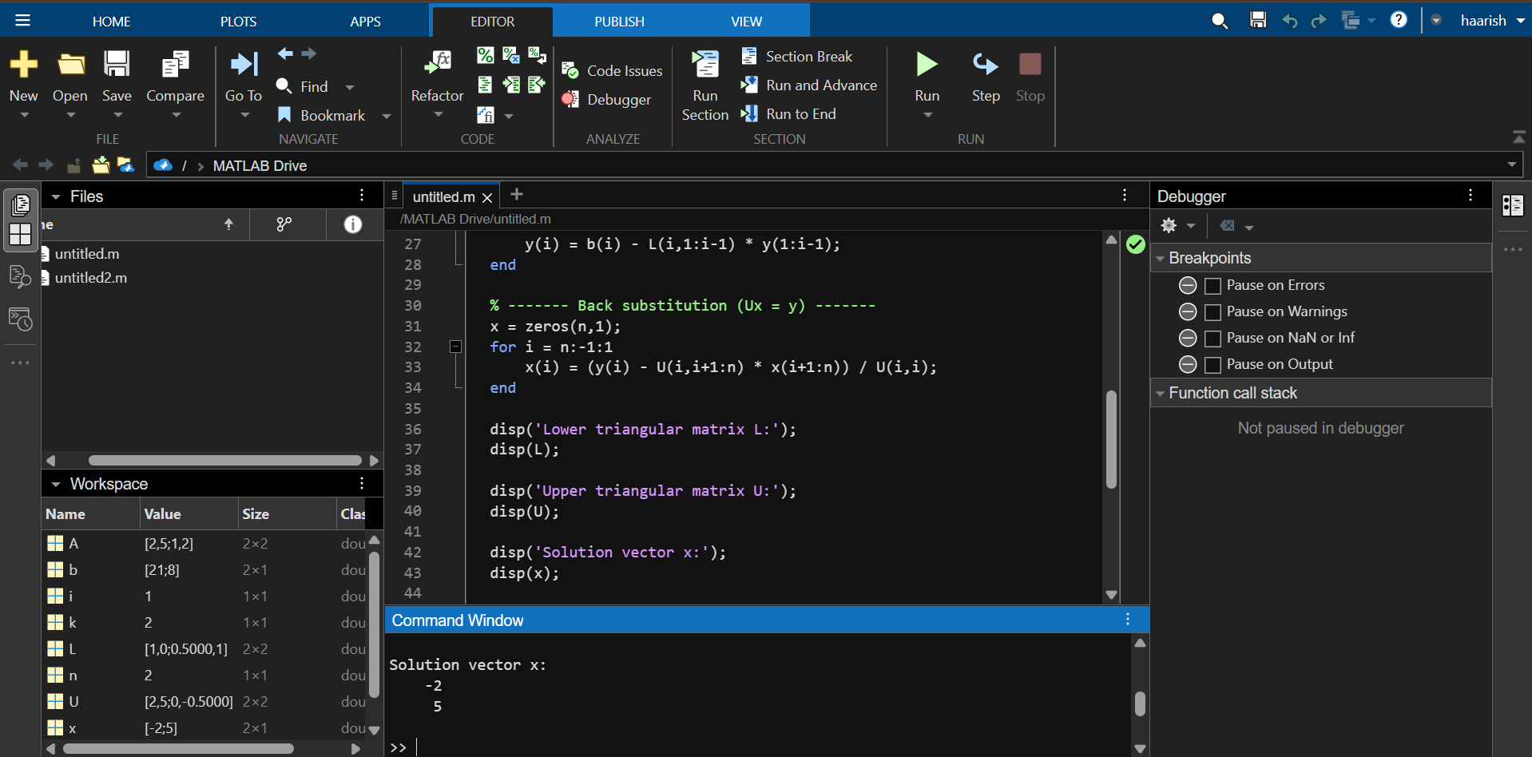

Rank of a matrix-echelon form
Problem:
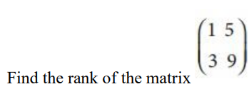
Aim:

Procedure:

clc; clear;

% Rank of a Matrix using Row Echelon Form (REF)

A = input('Enter matrix A: ');

[m, n] = size(A);
B = A; % Copy of A

row = 1;
for col = 1:n
% Find pivot (first non-zero entry in column)
pivot = find(B(row:m, col), 1) + row - 1;

% If pivot not found, go to next column
if isempty(pivot)
continue;
end

% Swap pivot row with current row
if pivot ~= row
temp = B(row,:);
B(row,:) = B(pivot,:);
B(pivot,:) = temp;
end

% Eliminate entries below pivot
for i = row+1:m
factor = B(i, col) / B(row, col);
B(i,:) = B(i,:) - factor * B(row,:);
end

row = row + 1;
if row > m
break;
end
end

% Count non-zero rows to find rank
rankA = sum(any(B ~= 0, 2));

disp('Row Echelon Form of A:');
disp(B);

disp(['Rank of the matrix A = ', num2str(rankA)]);

Output:
Eigen values, eigen vectors & Diagonalization

clc; clear;

% Program to find Eigenvalues and Eigenvectors of a Matrix

A = input('Enter matrix A: ');

% Eigenvalues
eigen_values = eig(A);

% Eigenvectors
[eigen_vectors, eigen_values_matrix] = eig(A);

disp('Eigenvalues of A:');
disp(eigen_values);

disp('Eigenvectors of A (columns correspond to eigenvalues):');
disp(eigen_vectors);

disp('Diagonal matrix of eigenvalues (for reference):');
disp(eigen_values_matrix);

Finding inverse and power of a matrix by Cayley-Hamilton Theorem

clc; clear;

% Cayley-Hamilton Theorem: Finding A^n and A^-1
A = input('Enter a square matrix A: ');
n = input('Enter the power n (positive or negative): ');

% Characteristic polynomial of A
syms x
char_poly = charpoly(A, x); % Returns coefficients of characteristic polynomial

disp('Characteristic Polynomial coefficients:')
disp(char_poly)

% Convert polynomial to symbolic expression
p = poly2sym(char_poly, x);
disp('Characteristic polynomial p(x) = ')
disp(p)

% --------- Find Inverse using Cayley-Hamilton (if det(A) ≠ 0) ----------
if det(A) ~= 0
% For inverse, we use: p(A) = 0 → express A^(-1) in terms of I, A, A^2, ...
syms k
I = eye(size(A));

% Compute A^(-1) using formula derived from characteristic polynomial
% For 2x2: A^2 - tr(A)A + det(A)I = 0 → A^-1 = (1/det(A)) * (tr(A)I - A)
% For 3x3 and higher, use symbolic solving

% Get polynomial coefficients
c = char_poly; % c = [1, a1, a2, ..., an]

% For 2×2 and 3×3 the formula is:
% A^(-1) = -(1/c(end)) * (c(2)*I + c(3)*A + c(4)*A^2 + ...)

A_inv = 0;
for k = 2:length(c)
A_inv = A_inv + c(k) * A^(k-2);
end
A_inv = -A_inv / c(end);

disp('Inverse of A using Cayley-Hamilton:')
disp(A_inv)
else
disp('Matrix has no inverse (det(A)=0)')
end

% ----------- Compute A^n using Cayley-Hamilton theorem -----------
if n >= 0
A_power = A^n; % direct computation (still consistent with CH theorem)
else
A_power = A_inv^abs(n); % use inverse from CH
end

disp(['A^', num2str(n), ' using Cayley-Hamilton theorem is:'])
disp(A_power)

